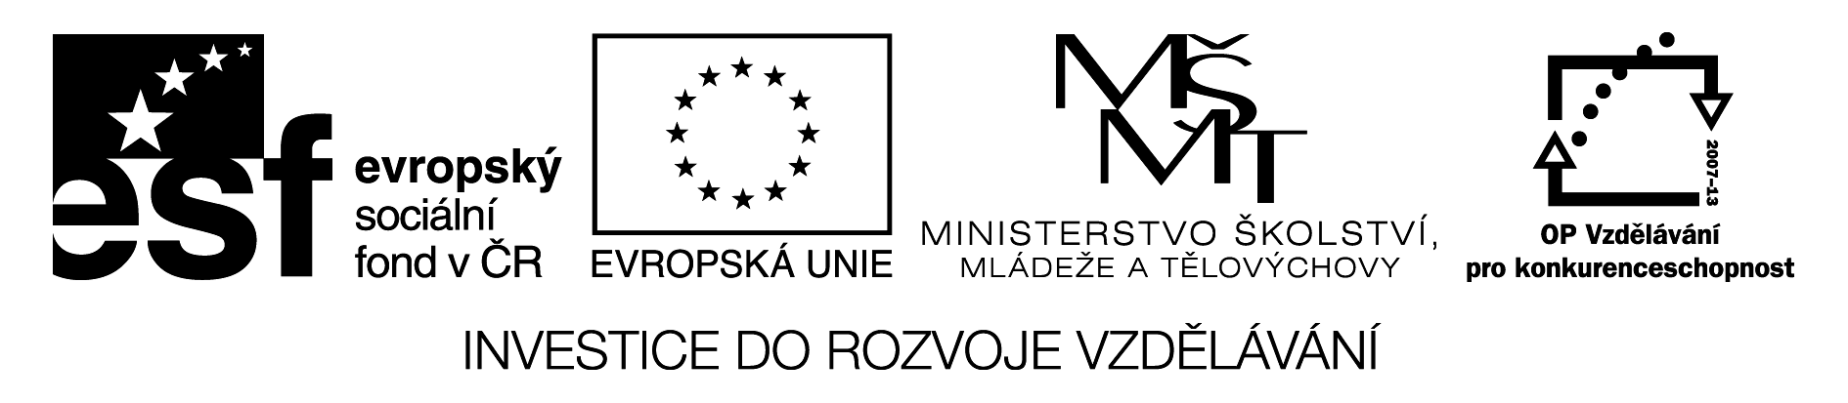

We to Spain by plane.
You tennis yesterday.
They a lot of museums.
He TV last night.
She in a bank last year.
They in London 10 years ago.
Joe stamps when he was a child.
We to the beach last Sunday.
I my friends at home.
Mum to go to the beach.

travelled | played | visited | watched
worked | lived | collected | walked
phoned | wanted | started | waited
stayed | grabbed | shouted | checked
travelled | played | visited | watched
worked | lived | collected | walked
phoned | wanted | started | waited
stayed | grabbed | shouted | checked
travelled | played | visited | watched
worked | lived | collected | walked
phoned | wanted | started | waited
stayed | grabbed | shouted | checked
travelled | played | visited | watched
worked | lived | collected | walked
phoned | wanted | started | waited
stayed | grabbed | shouted | checked

Popis a instrukce:

Žáci pracují samostně nebo ve dvojicích.
Každý má svůj vlastní list s větami (je možno zatavit do fólie a používat tak opakovaně) a sadu sloves. Hledají vhodné sloveso do věty, sloves je záměrně více, aby žáci opravdu použili to správné sloveso a rozuměli větám.
Kontrola probíhá společně.

Řešení:
Travelled, played, visited, watched, worked, lived, collected, walked, phoned, wanted

